INDIAN SCHOOL AL WADI AL KABIR
Class: XII Comp. Sci. | Department: Computer Science
Worksheet No: 08 | Topic: Computer Networks | Note:

1 | What is computer Network?
2 | What are the advantages and disadvantages of Computer Network?
3 | Explain the evolution of network.
4 | Write short note on  - ARPANET  - NSFNET  - Internet
5 | Write the full form of  - ISP  - Pop  - ARPANET  - NSFNET  - TCP/IP
6 | Explain the following.  Sender ii)Receiver iii)Message iv)Communication media v)Protocol
7. | Write short note on:  - IP addres  - Switching Techniques  - Circuit switching  - Packet Switching
8 | Give the characteristics, advantages and disadvantages of the following.  i) Twisted pair cable ii) Co-Axial Cable iii) Fiber-optic cable  iv)Radio wave v) Micro wave vi) Infrared wave
9 | Explain the function of:  i) Modem ii) Ethernet card iii) RJ45 iv) Repeater v) Hub  vi) Switch vii) Router
10 | What do you mean by Network Topology? Explain Bus, Star and Tree topologies.
11 | Name the purpose, full form, why and where the following protocols are used  - HTTP ii) FTP iii) PPP iv) SMTP v) TCP/IP  vi) POP3 vii) HTTPS viii) TELNET ix) VOIP
12 | What do you mean by web services?
13 | Explain the purpose of the following  - WWW ii) HTML iii) XML iv) domain names v) URL vi) Web site  - Web browser Web servers ix) Web hosting
14 | Helping Hands is an NGO with its head office at Mumbai and branches located at Delhi, Kolkata  and Chennai. Their Head Office located at Delhi needs a communication network to be established  between the head office and all the branch offices. The NGO has received grant approval from the  Central Government for setting up the network. The physical distances between the branch offices  and the head office and the number of computers to be installed in each of these branch offices and  the head office are given below. As a network expert you have to suggest the best possible  solutions for the queries as raised by the NGO, as given in (i) to (iv).  Distances between various locations in Kilometres :  Mumbai H.O. to Delhi 1420  Mumbai H.O. to Kolkata 1640  Mumbai H.O. to Chennai 2710  Delhi to Kolkata 1430  Delhi to Chennai 1870  Chennai to Kolkata 1750  Number of Computers installed at various locations are as follows :  Mumbai H.O. 2500  Delhi Branch 1200  Kolkata Branch 1300  Chennai Branch 1100  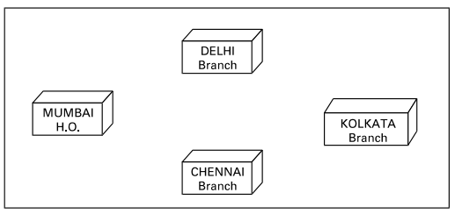  (i) Suggest the drawing the best cable layout for effective network connectivity of all the Branches and the Head Office for communicating data.  (ii) Suggest the most suitable location to install the main server of this NGO to communicate data with all the offices.  (iii) Write the name of the type of network out of the following, which will be formed by connecting all the computer systems across the network :  (A) WAN  (B) MAN  (C) LAN  (D) PAN  (iv) Suggest the most suitable medium for connecting the computers installed across the network out of the following :  (A) Optical fibre  (B) Telephone wires  (C) Radio Waves  (D) Ethernet cable
15 | Ayurveda Training Educational Institute is setting up its centre in Hyderabad with four specialised departments for Orthopedics, Neurology and Pediatrics along with an administrative office in separate buildings. The physical distances between these department buildings and the number of computers to be installed in these departments and administrative office are given as follows. You, as a network expert, have to answer the queries as raised by them in (i) to (iv).  Shortest distances between various locations in metres :  Administrative Office to Orthopedics Unit 55  Neurology Unit to Administrative Office 30  Orthopedics Unit to Neurology Unit 70  Pediatrics Unit to Neurology Unit 50  Pediatrics Unit to Administrative Office 40  Pediatrics Unit to Orthopedics Unit 110  Number of Computers installed at various locations are as follows :  Pediatrics Unit 40  Administrative Office 140  Neurology 50  Orthopedics Unit 80  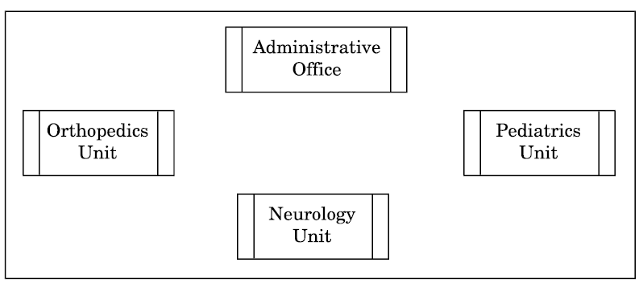  (i) Suggest the most suitable location to install the main server of this institution to get efficient connectivity.  (ii) Suggest the best cable layout for effective network connectivity of the building having server with all the other buildings.  (iii) Suggest the devices to be installed in each of these buildings for connecting computers installed within the building out of the following :  - Gateway  - Modem  - Switch  (iv) Suggest the topology of the network and network cable for efficiently connecting each computer installed in each of the buildings out of the following :  Topologies : Bus Topology, Star Topology  Network Cable : Single Pair Telephone Cable, Coaxial Cable, Ethernet Cable

